|  |  |
| --- | --- |
| <<Provider_Suitname>> | February 18, 2022 |
| Via E-mail | |

**RE:***§57.105 Motion for Sanctions*

**Case:** *<<Provider_Suitname>> A/A/O <<Injuredparty_Name>> v. <<Insurancecompany_Suitname>>*

**Case No.:** *<<Indexoraaa_Number>>*

Dear Client,

*<<Insurancecompany_Suitname>>* has filed the attached motion for sanctions under F.S. §57.105, claiming that the action brought on your behalf against it is frivilous and without merit. Said motion expires 20 days from the date of the motion (the “*Safe Harbor Period*”). The Motion explains clearly the basis for *<<Insurancecompany_Suitname>>’s* contentions, but we urge you to call us immediately to further discuss this matter.

At this juncuture, your options are to file a Notice of Voluntary Dismissal without prejudice prior to the expiration of the *Safe Harbor Period* and completely avoid any potential sanctions, or to continue the litigation, and if the case is lost at or prior to trial, *<<Insurancecompany_Suitname>>* couldbe entitled to recover from you its reasonable costs and attorneys’ fees incurred in defense of this action.

Please sign and return the acknowledgement below prior to the expiration of the *Safe Harbor Period* indicating your decision to voluntarily dismiss this action or to continue with the litigation. If we do not receive your signed letter by the expiration of the *Safe Harbor Period*, we will assume you would like to continue with the litigation.

Again, we urge you to call us to discuss this matter furhter.

Sincerely,

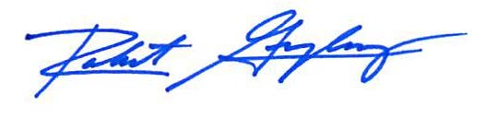

Robert F. Gonzalez, Esq.

**Case:** *<<Provider_Suitname>> A/A/O <<Injuredparty_Name>> V. <<Insurancecompany_Suitname>>, Case No. <<Indexoraaa_Number>>*

ACKNOWLEDGEMENT

I hereby decide to (sign next to your decision):

1. Proceed with my case __________________________ _______________

Signature of client representative Date

1. Voluntarily dismiss my case __________________________ _______________

Signature of client representative Date